A Mathematical Tug-of-War
Activity Card

As a group –
- Read the two rounds of a Mathematical Tug-of-War described on the Resource Card.

- Gather any materials available to make a model or a design of the balanced first and second rounds.

- Use mathematical representations to express the balance.

- Read the third round. Figure out whether this round will or will not be a draw. Prepare to explain your thinking.

Group task
Design a fourth, particularly tricky tug-of-war with Basil, five grandmas, and four giant- mutant-ninja-frogs that will not come out even. Make a poster to share with the class and explain your solution.

Evaluation criteria:
- You can justify your solution to the tricky tug-of-war in at least two ways.
- Your poster is well-organized and reflects the contributions of all members of the group.

A Mathematical Tug-of-War
Resource Card
The results are in…

First round:
On one side there are 4 giant- mutant-ninja-frogs who have come out of their pond for this special event. All 4 are of equal strength. On the other side are 5 grandmas, a tugging team that has practiced tugging for many years. They too are all of equal strength. In the contest between the two teams, the result is even.

Second round:
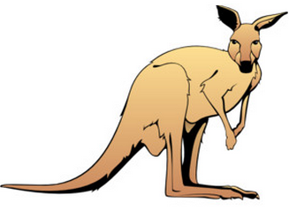
On one side is Basil, the specially trained kangaroo who developed a unique tugging style when she was just a joey. Basil is up against a team made of 2 grandmas and 1 giant- mutant-ninja-frog. Once again, the result is a draw.

The third round is about to begin:
By now they are all good friends. So Basil asks 1 grandma and 2 giant- mutant-ninja-frogs to help her in a tug-of war against a team of 3 grandmas and 3 giant- mutant-ninja-frogs. We want to know how this round will end!

Name___________________________
A Mathematical Tug-of-War
Individual Report
- Record the first and second round of the tug-of-wars in mathematical terms.
Round 1:

Round 2:

- Explain the outcome of round 3.

- In your opinion, what made your group’s design of the fourth round particularly tricky or not tricky enough?

Evaluation Criteria:
- The individual report is complete.
- You used mathematical representation to explain and describe the various rounds.

Adapted from Marilyn Burns, Math for smarty pants © Program for Complex Instruction, Stanford, 2015

